TITLE IX
BY FRANK MUZZOPAPPA
As the year 2016 begins its first quarter, I reflect on one of the major news stories which were of the U.S. Women’s World Cup triumph in soccer. It was a repeat of the successful effort the 1999 Women’s World Cup champions.
The games dominated the news outlets for weeks. References were made regarding Mia Hamm, a star athlete of the 1999 team. Mia was born in 1972, the year that Title IX was enacted to enable female athletes the opportunity to participate in team sports with the same privileges accorded males.
Mia was considered by many advocates as a member of the first generation of female athletes that were recipients of Title IX. I reflected on the impact of Title IX, and the young women of previous generation’s determination to bring it about.
World War II ended in 1945, and women had broken the barriers that precluded them from jobs previously denied. Ostensibly, it would only be a matter of time that women would prevail in their determination to reach equal status in areas that previously denied them equal opportunity.
In 1946, my sophomore year at Avella High School, the female students were making it known that they wanted to compete with the students of high schools with whom the males engaged in basketball competition.
Mr. John Caldwell, an elementary teacher, had a background in Physical Education. He was approached to organize a female team and set up a schedule. Mr. Caldwell also taught the Health Course to the high school students, which would facilitate the whole process between administrators, students and Mr. Caldwell.
Thirteen students turned out for the team that first year: one senior, six juniors, five sophomores and one freshman. Those from Penowa were Margaret Korpos and Stefana Koltick. Margaret was a sophomore and Stefana was a junior. Another student from the sophomore class was Janet DePetro. Janet’s father came to Penowa at the age of 16 as an Italian immigrant. With the help of George Tranquill family and Albert Miller, Joe DePetro worked as a farm hand for a few years before entering the U. S. Army during World War I. After the war he returned home married, and worked in the Penobscot mine in Penowa for several years before moving to Independence.…. my way of relating to her roots in Penowa.
Margaret never touched a basketball until her high school days, but she had good natural talent. In elementary school, she competed as well as the best males in softball. Whereas Janet told me that she played basketball with her brothers, Joe and Robert, before high school.
Women’s basketball, in those years, was played differently than it is today. The rules for women consisted of six women per team: three guards and three forwards. Neither the guards nor the forwards were permitted to cross the center-line of the court. Margaret, who admittedly defined herself as a “Tomboy”, had good coordination, strong hands, and the ability to fling the ball down court to the forwards. Stefana was able to force her way under the basket to retrieve the ball, and pass it off to another guard to get the ball to the forwards.
Janet, on the other hand, had honed in on shooting baskets with her brothers. Janet was usually the high scorer for the team. Janet, Margaret and Stefana were well suited for their position on the team.
Other than Janet and Margaret, in my class, there were Ann Kosarick, a quick and in your face type of guard. Alma Long and May Bosseau were forwards.
I believe that it was the grit and determination of women such as them that ultimately led to Title IX.
Margaret, Ann and Alma have passed away, but I am still in touch with Janet and May. Another member of that team is Evelyn (Ricco) Brandenberg, with whom I have phone conversations and maybe a visit during the high school reunions. At 86 years of age, she is as energetic as she can be for her church, family and community. Women with the moxie that represents the individualism of the others, that made up that great “First Team”.
The Record for That First Year Team

Avella 23…………Hickory……….…….…14
Avella 17……..….West Alexander…..17
Avella 28…………West Alexander..…24
Avella 40…………Midway……………….28
Avella 41………...Hickory……………..…21
Avella 32……..….West Alexander..…24
Avella 38……..….Peters Township…..40
Avella 26……..….Peters Township…..22

THAT FIRST TEAM

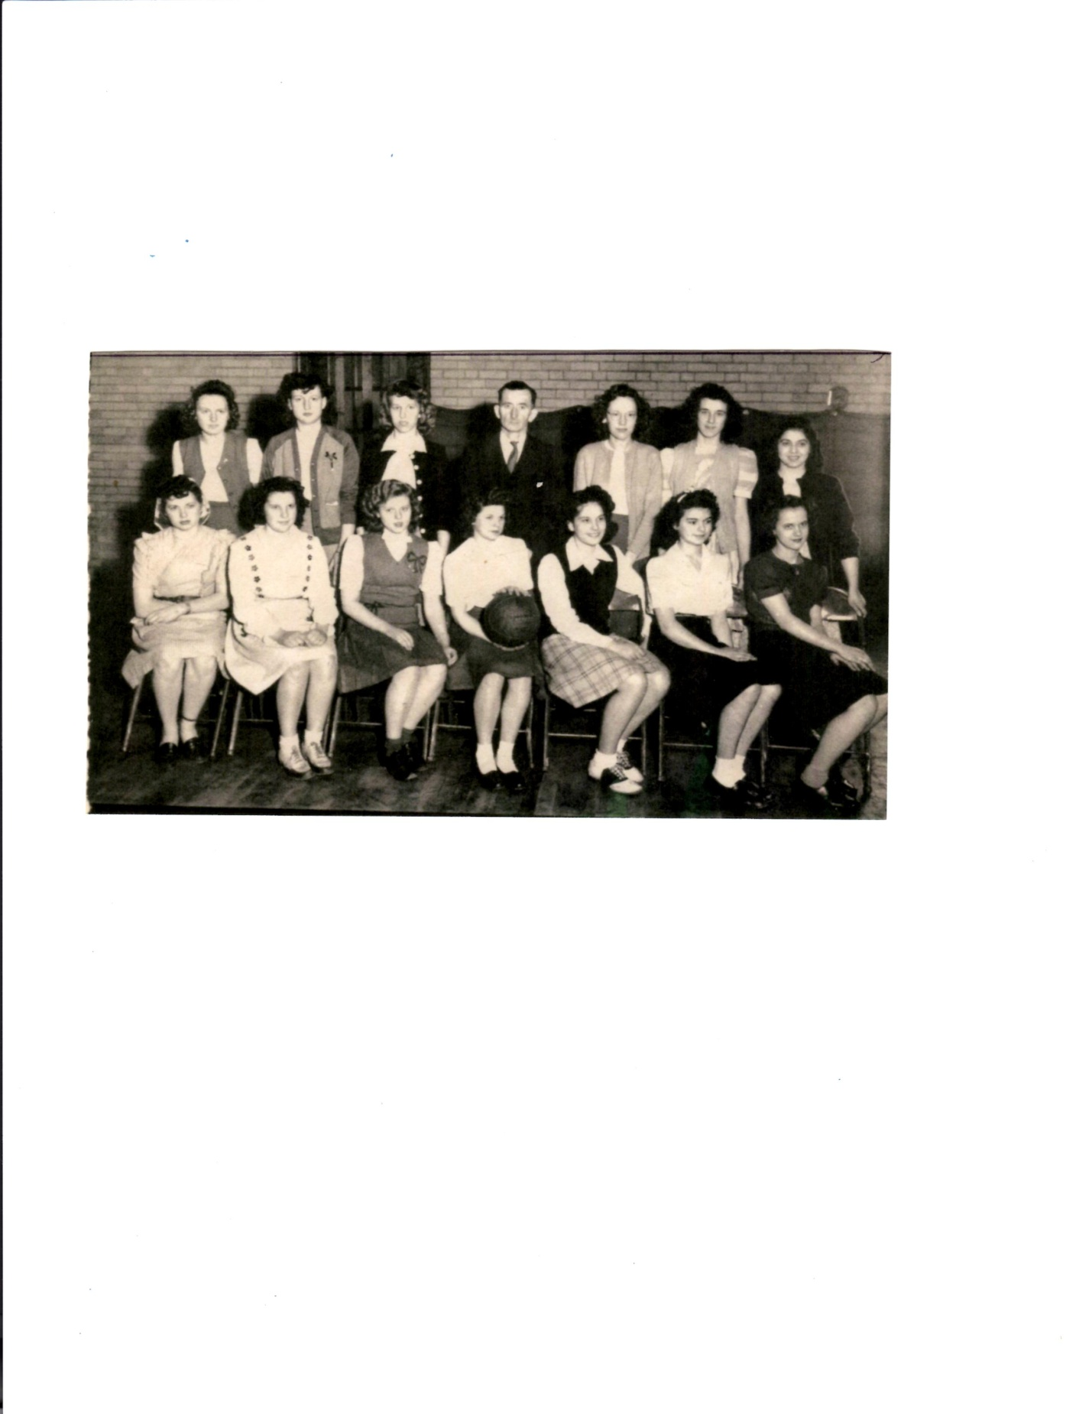

LEFT TO RIGHT-SEATED: MARY MARIANI, STEFANA KOLTICK, CHARLENE THOMPSON,
VERONICA SINICHK, JANET DePetro, ANN KOWCHECK, MAY BOSSEAU
STANDING: MARGARET KORPOS, LOUISE GROSS, MERCEDES KOWCHECK, Mr. JOHN CALDWELL,
ALMA LONG, EVELYN ROCCO, MARY FERRARE

